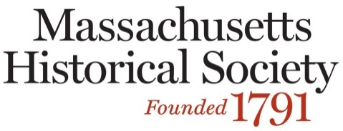

**Painless: A Survival Guide to the Dreaded History Project**

**October 22, 2016**

Name:

School or District & Grade level Taught (if applicable):

Home Address:

City:

State:

Zip:

Email (Required):

Registration fee: $10 (FREE for students)

Payment:

___Check is enclosed (payable to MHS)

___Visa ___MasterCard ___American Express ___Discover

Card Number:

Expiration Date:

Signature:

Name on Card:

Please print this form, fill it out, and return it with your payment to:

Debbie Beardsley

Massachusetts Historical Society

1154 Boylston Street

Boston, MA 02215

[education@masshist.org](mailto:education@masshist.org)

617-646-0570